Experiment worksheet

7.1 A force is a push or a pull

Pages 120–121 and 202

Experiment 7.1: Measuring forces

Aim

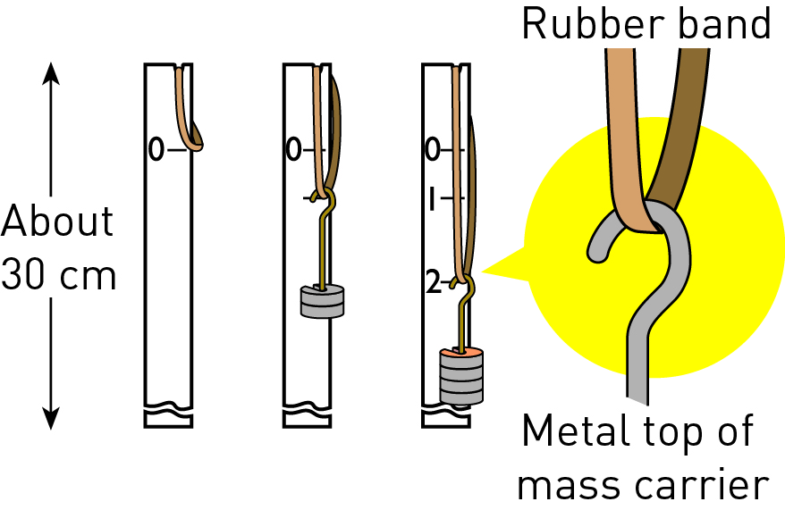

**Figure 1**

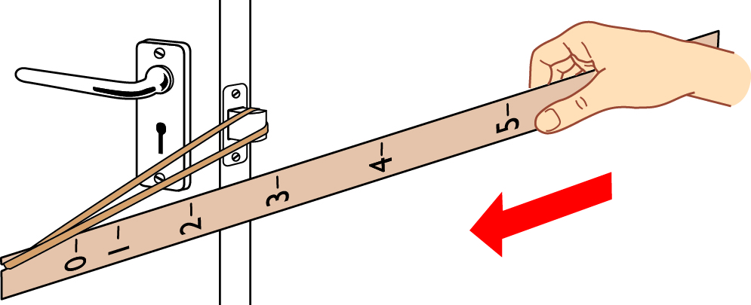

**Figure 2**

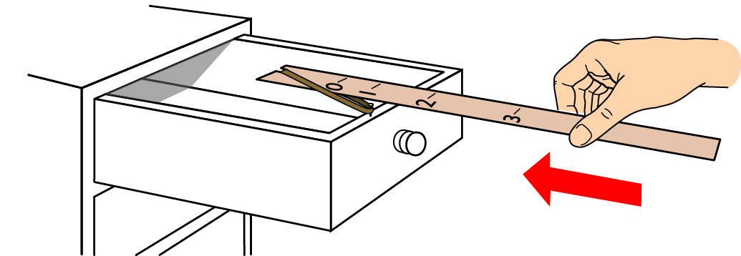

**Figure 3**

To measure a variety of forces in common situations.

Materials

• Rubber band

• Thin strip of timber (or a ruler)

• Mass carrier and masses

• Pen

Method

A rubber band can measure the size of forces in a similar way to a spring balance. But before it can, it must be calibrated. This means matching the stretch of the rubber band to the number of newtons pulling on it.

1 Calibrate the rubber band on the strip of timber as shown in Figure 1.

2 Mark the distance that the rubber band is stretched on the timber when the mass carrier holds a 100 g mass. Remember: The weight force of 100 g equals 1 N of force.

3 Repeat for masses of 200 g, 300 g, 400 g and so on, marking the timber each time.

4 Use your measuring device to measure the force needed to:

a open the door to the room

b drag a chair across the floor

c close a drawer in the laboratory

d move your pencil case

e pull up your sock

f do three other movements of your choice.

Results

Draw a column graph showing the amount of force needed to move each object.

Experiment worksheet

7.2 An unbalanced force causes change

Pages 122–123 and 203

Challenge 7.2: Design a ball whacker

Design brief

Design equipment that uses a block of wood to hit a tennis ball. A block of wood from home or the woodwork room is ideal. You must not use the force of gravity or push the block.

Questioning and predicting

1 How will you create a contact force between the wooden block and the ball?

2 How will you make the wooden block swing?

3 How far do you want your ball to move?

Planning and conducting

The figure below shows one way to set this up. Suggest two ways to modify this design.

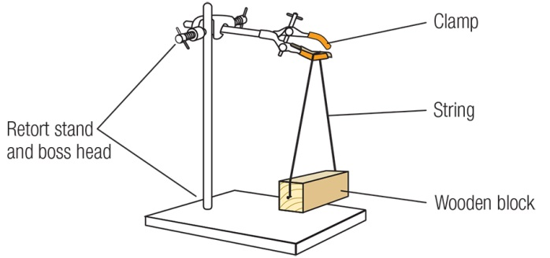

Processing, analysing and evaluating

1 What changes did you have to make to move the ball further?

2 What was the most successful feature of your ball whacker? What was the least successful?

3 Is a heavy block better than a light one?

4 Is there any practical use for a ‘whacker’ like this?

5 If you were doing this experiment again, how would you modify your device? Explain.

Communicating

Present the various stages of your investigation in a formal experimental report.

Experiment worksheet

7.3 Forces can be contact or non-contact

Pages 124–125 and 203

Challenge 7.3: Can you use the push and pull of a magnet?

Design brief

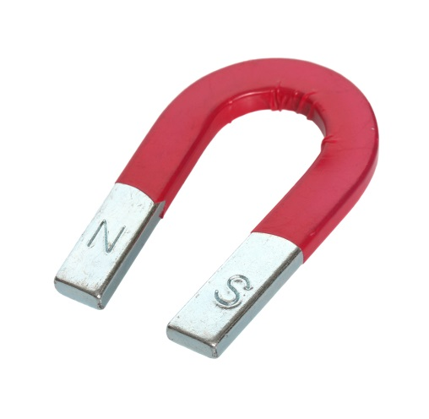Choose one of the following design briefs.

1 Have a magnet race. Who can push a magnet across the length of a desk the fastest using another magnet?

2 Can you use the push force between two magnets to suspend the end of one magnet above the end of the other?

3 Design an experiment to determine how far away your magnet needs to be to attract a metal paperclip. What if you used another magnet? Design an experiment to test if the second magnet has a stronger pulling force than the first magnet. Remember to control all other variables.

Questioning and predicting

1 Should you use like or unlike poles?

2 Do all magnets have equal force?

3 Which part of a magnet has the strongest force?

Processing, analysing and evaluating

1 What changes did you have to make to improve your design?

2 What was the most successful feature of your design? What was the least successful?

3 Is there any practical use for your design?

4 If you were doing this experiment again, how would you modify your design? Explain.

Communicating

Present the various stages of your investigation in a formal experimental report.

Experiment worksheet

7.5 Electrostatic forces are non-contact forces

Pages 128–129 and 204

Experiment 7.5: What if a balloon were electrostatically charged?

Aim

To examine the push or pull forces involved in electrostatically charged balloons.

Materials

• Two balloons

• String

• Wool/nylon material

Method

1 Blow up both balloons and tie knots in the ends.

2 Tie string to the ends of both balloons.

3 Rub one of the balloons on your jumper or with the material provided.

4 Hold the balloon by the string so that it does not lose its charge.

5 Hold the second balloon by the string and bring it close to the first balloon.

6 Would you describe the force as a push or pull force?

7 Does the balloon have to make contact for the force to be noticed?

Inquiry: What if both balloons are charged?

1 What (independent) variable will you change from the first method?

2 What (dependent) variable will you measure and/or observe?

3 Name three variables you will keep the same or control.

4 Write a hypothesis for your inquiry.

5 Describe what happened.

6 Explain why it happened.

Experiment worksheet

7.6 Friction slows down moving objects

Pages 130–131 and 205

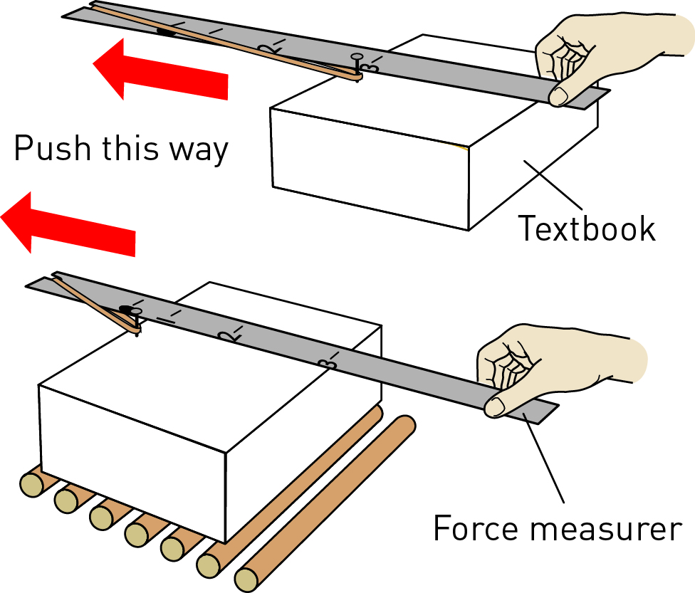Experiment 7.6: What if the amount of friction were changed?

Aim

To investigate how friction may be reduced.

Materials

• Force measurer (see Experiment 7.1) or spring balance

• Thick textbook

• Wooden rollers (round pencils)

• Book

• Sand

Method

1 Use your force measurer to measure the friction of your textbook being dragged along the table. (Hint: Drag it at constant speed.)

2 Place two books on top of each other and measure the friction.

Inquiry: Choose one question to investigate.

• What if rollers were placed under the textbook?

• What if sand was placed under the textbook?

1 Write a hypothesis for your inquiry.

2 What (independent) variable will you change from the first method?

3 What (dependent) variable will you measure and/or observe?

4 What variables will you need to control to ensure a fair test? How will you control them?

Results

Record your results in the table below.

|  |  |  |  |  |
| --- | --- | --- | --- | --- |
| OBJECT | FORCE NEEDED TO MAKE IT MOVE (N) | | | |
|  | Trial 1 | Trial 2 | TrIAl 3 | Average |
| Textbook |  |  |  |  |
| Textbook with a second book on it |  |  |  |  |
| Textbook with rollers under it |  |  |  |  |
| Textbook with sand under it |  |  |  |  |

Draw a column graph in the space provided showing the effect of sand or rollers on the object’s friction.

|  |
| --- |
|  |

Discussion

1 Compare your results to those of others in the class.

2 What was the best way to reduce friction?

3 Would five rollers be better than two for reducing friction?

4 Would 10 rollers be better than five for reducing friction?

5 Would bigger or smaller rollers be better for reducing friction?

6 What are some problems with using rollers?

7 Write down a practical example of rollers being used to reduce friction.

8 Why wouldn’t square rollers be any good?

9 Would fine sand or coarse (large-grained) sand be better for increasing friction?

10 Write down a practical example of sand being used to increase friction.

11 What are some problems with using sand for this purpose?

Conclusion

What do you know about how to reduce friction?

Experiment worksheet

7.7 Simple machines decrease the amount of effort needed to do work

Pages 132–133 and 206

Experiment 7.7A: Using a first-class lever to lift weights

Aim

To determine how a first-class lever balances different weights.

Materials

• Wooden or metal ruler

• 50 g weights

• Rounded glue stick or a large pencil

• Blu-Tack

Method

1 Place the glue stick or pencil flat on the desk and hold it in place with Blu-Tack.

2 Place the centre of the ruler over the glue stick or pencil so that it forms a simple see-saw.

3 Add three 50 g weights 4 cm from the centre of fulcrum on one side.

4 Add three 50 g weights to the other side so that the see-saw becomes balanced.

Inquiry: Choose one question to investigate

1 What if a greater weight was placed closer to the fulcrum?

2 What if greater weight was placed further from the fulcrum?

3 What if less weight was placed closer to the fulcrum?

4 What if less weight was placed further from the fulcrum?

Results

Record your results by completing the table.

|  |  |  |  |  |  |
| --- | --- | --- | --- | --- | --- |
| LEFT-HAND SIDE | | | RIGHT-HAND SIDE | | |
| Number of weights | Position from fulcrum (cm) | Number of weights x distance from fulcrum | Number of weights | Position from fulcrum (cm) | Number of weights x distance from fulcrum |
| 3 | 4 | 12 | 3 |  |  |
| 3 |  |  | 2 |  |  |
| 3 |  |  | 1 |  |  |
| 1 |  |  | 5 |  |  |

Discussion

1 What pattern do you notice between the left-hand side and the right-hand side of your first-class lever?

2 What is mechanical advantage?

3 Calculate the mechanical advantage of the lever when the single weight on the left-hand side lifts the five weights on the right-hand side.

4 Provide another example of a first-class lever that you have used.

Conclusion

Draw and label a first-class lever and describe how to determine its mechanic advantage.

|  |
| --- |
|  |

Experiment worksheet

7.7 Simple machines decrease the amount of effort needed to do work

Pages 132–133 and 207

Experiment 7.7B: Using a second-class lever to lift weights

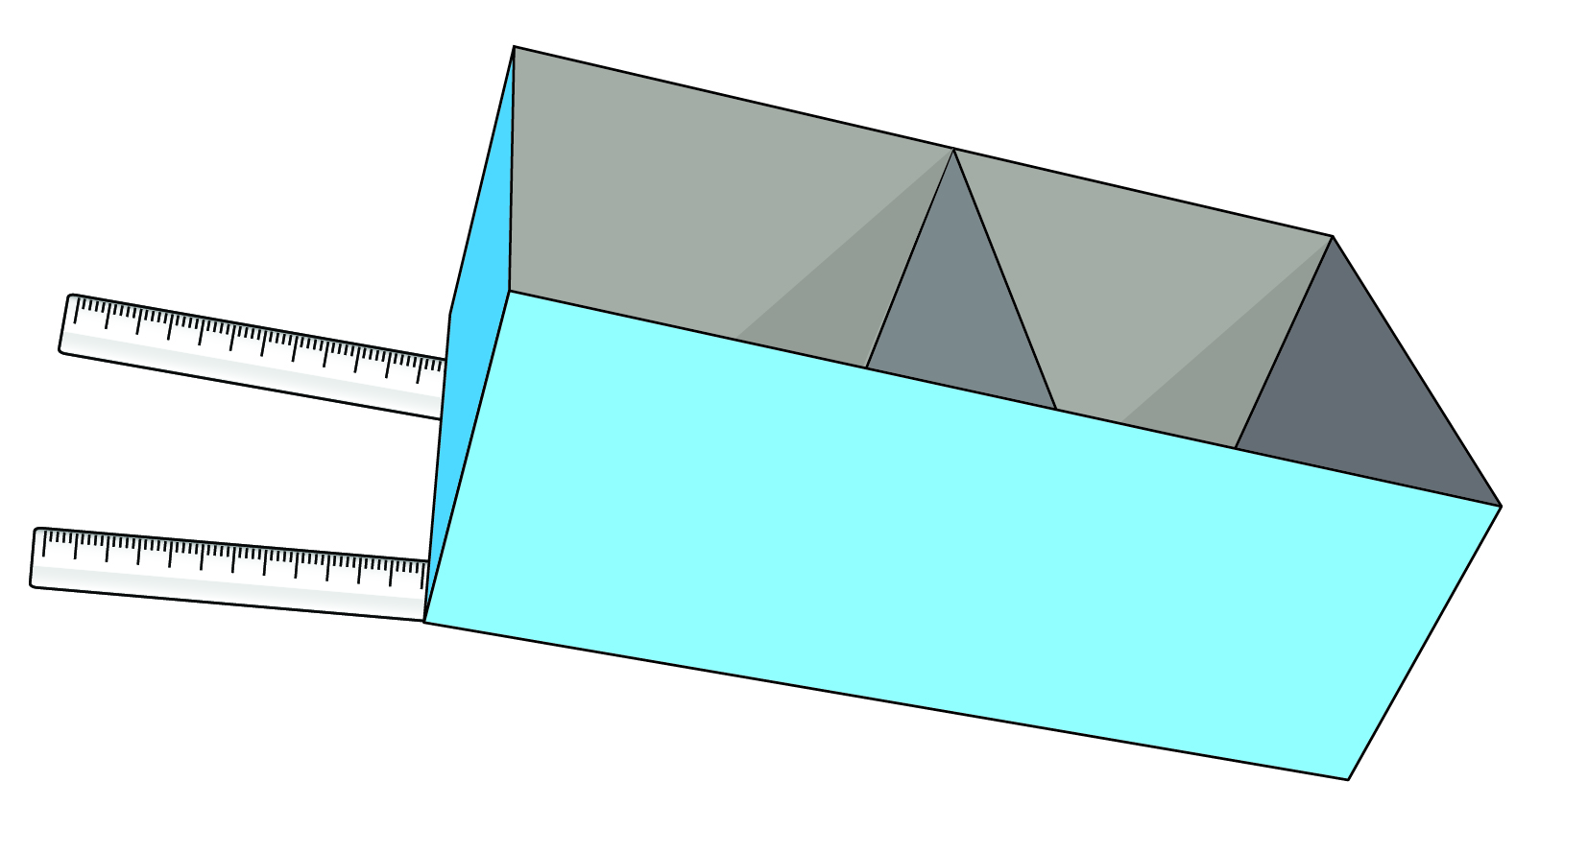Aim

To investigate the mechanical advantage of a second-class lever.

Materials

• Shoebox

• 2 spring balances

• Carboard

• Sticky tape

• 2 rulers

• Weights

Method

1 Use sticky tape to stick the rulers together in a V shape.

2 Divide the shoebox into two compartments using the cardboard.

3 Attach the box on the top of the rulers so that it looks like a wheelbarrow with a front and rear compartment.

4 Add weight to the front of your second-class lever.

5 Use the spring balances on the handles to calculate the total effort force need to lift this weight.

6 Repeat this measurement three times.

Inquiry: What if the weight were placed further from the fulcrum?

1 Write a hypothesis for your question.

2 What (independent) variable will you change from the first method?

3 What (dependent) variable will you measure and/or observe?

4 Name three variables you will keep the same or control.

5 Record your measurements in a table.

Results

Complete the following table to show the effort required when the front of the wheelbarrow is loaded.

|  |  |  |  |
| --- | --- | --- | --- |
|  | Spring balance 1 | Spring balance 2 | Total effort |
| Attempt 1 |  |  |  |
| Attempt 2 |  |  |  |
| Attempt 3 |  |  |  |
| Average |  |  |  |

Complete the following table to show the effort required when the rear of the wheelbarrow is loaded.

|  |  |  |  |
| --- | --- | --- | --- |
|  | Spring balance 1 | Spring balance 2 | Total effort |
| Attempt 1 |  |  |  |
| Attempt 2 |  |  |  |
| Attempt 3 |  |  |  |
| Average |  |  |  |

Discussion

1 Why did you repeat each measurement three times?

2 Describe the difference in total effort required when the weight was shifted further from the fulcrum on the second-class lever.

3 What does this suggest about how a wheelbarrow should be loaded by its user?

Conclusion

Describe the mechanical advantage of using a second-class lever.

Experiment worksheet

7.8 A pulley changes the size or direction of force

Pages 134–135 and 208

Experiment 7.8: Calculating mechanical advantage

Aim

To see how the number of pulleys affects the effort needed to lift a load and the distance this load travels.

Materials

• Retort stand

• 500 g weight

• Spring balance

• Set of pulleys

• String

Method

1 Set up four pulley systems using one, two, three and four pulleys.

2 Pull on the spring balance to raise the load by 10 cm.

3 Record the average reading on the spring balance and the distance moved by the spring balance.

4 Calculate the mechanical advantage in each case.

Results

1 Complete the following table.

|  |  |  |  |
| --- | --- | --- | --- |
| Number of pulleys | Effort reading on the spring balance (N) | Distance the effort has to move (cm) | Mechanical advantage (load ÷ effort) |
| 1 |  |  |  |
| 2 |  |  |  |
| 3 |  |  |  |
| 4 |  |  |  |

2 Draw a column graph showing the relationship between the number of pulleys and the mechanical advantage.

|  |
| --- |
|  |

Discussion

1 What happens to the effort needed to lift the 500 g load as more pulleys are used?

2 What happens to the distance the effort moves compared to the distance the load moves?

3 What would the spring balance read if six pulleys were used to lift the 500 g load?

4 What length of string would have to be pulled through the pulleys to lift the 500 g load 20 cm upwards?

Conclusion

Write a statement that relates the number of pulleys to the size of the effort and the distance moved by the load.

Experiment worksheet

7.9 There are different types of machines

Pages 136–137 and 208

Experiment 7.9: Comparing different machines

A INCLINED PLANE

Materials

• 500 g mass (with a hook to attach to the spring balance)

• Ramp (30 cm ruler or a wider or longer piece of thin wood or plastic)

• Shoebox (or pile of books or plastic tub upside down)

• Spring balance

• Metre ruler

Method

1 Measure and record the height of the shoebox (or pile of books).

2 Measure and record the force required to carefully lift the 500 g mass vertically at a constant speed onto the top of the box.

3 Repeat step 2 several times and calculate an average force.

4 Position the ramp against the box and measure and record its length.

5 Slowly pull the 500 g mass up the ramp using the spring balance and record the force required.

6 Repeat step 5 several times to get an average force.

7 Which method provided the greatest mechanical advantage? What evidence do you have to support your conclusion?

8 A student claimed an incline plane was not a machine. Were they correct? Use evidence from the experiment to support your answer.

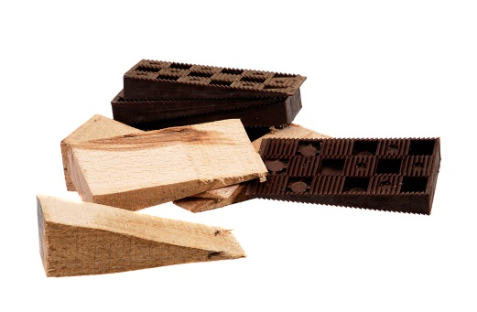B WEDGES

Materials

• 2 blocks of wood

• 2 thick, tight rubber bands

• Wedge-shaped piece of wood

Method

1 Place the rubber bands over the two pieces of wood to hold them tightly together.

2 Try pulling the blocks apart with your hands.

3 Place the pointed edge of the wedge between the two blocks and push it in.

4 What advantage did using a wedge have on separating the two blocks of wood?

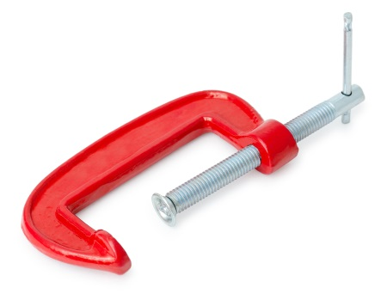

C SCREW

Materials

• G-clamp

• Matchbox

Method

1 Try crushing the matchbox using only your fingers, but don’t actually crush it.

2 Place the matchbox between the faces of the G-clamp and tighten it until it crushes.

3 Did using the screw mechanism in the G-clamp provide a mechanical advantage in crushing the matchbox? Describe the differences you noticed between using the two methods.

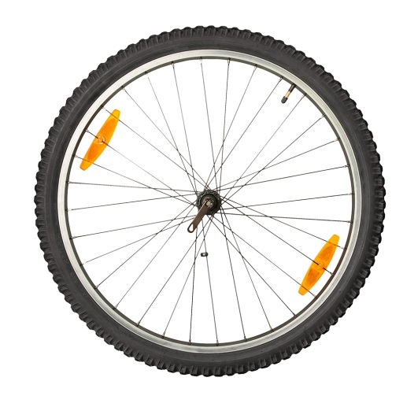D WHEELS AND AXLES

Materials

• Simple machine kit with a wheel and axle model or one made from Lego® or K’NEX®

• Cotton thread or string

• 2 weights

Method

1 Design and build your own working model of a wheel and axle simple machine.

2 Use cotton thread or string and two weights to demonstrate how your model can work as a force magnifier.

3 Modify your model or build another one to demonstrate how it can work as a distance magnifier.

4 How is a force magnifier different from a distance magnifier?

5 What did you change for the second model?

6 Why did you decide to change this aspect?